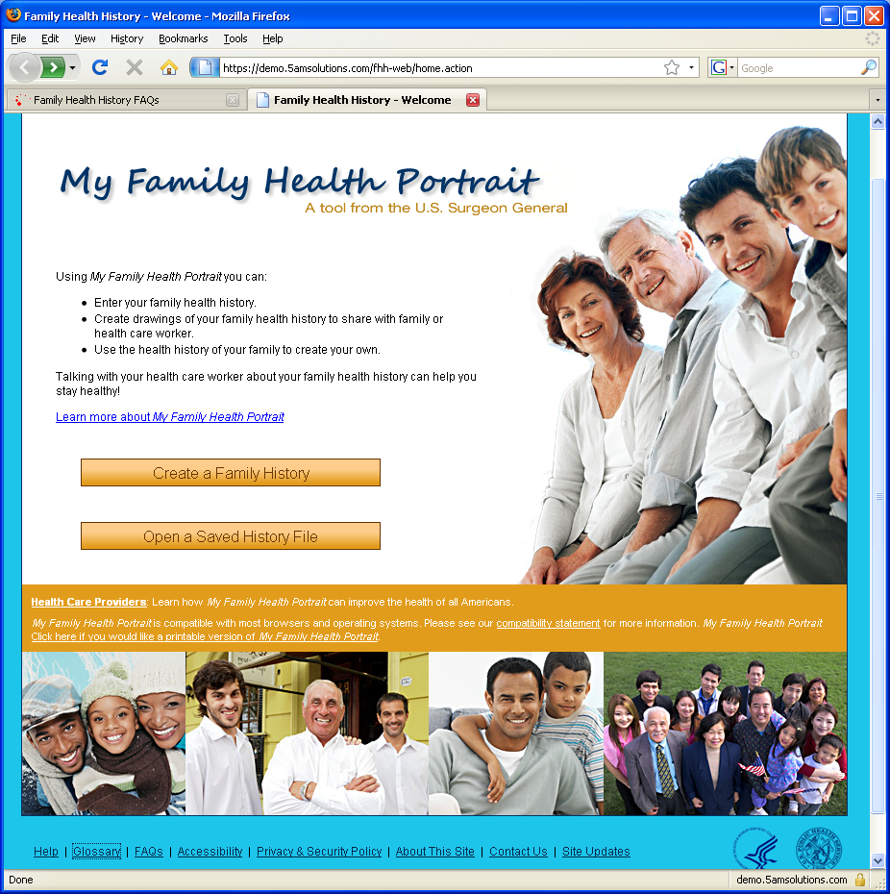

Help: Link to generalized help page
Glossary: Link to Glossary
FAQs: Link to http://www.hhs.gov/faq/diseases/familyhealthhistory/index.html
Accessibility: Link to http://www.hhs.gov/Accessibility.html
Privacy & Security Policy: Link to http://www.hhs.gov/Privacy.html
About this Site: See content below.
Contact Us: See content below.
Site Updates: See below

About My Family Health Portrait
My Family Health Portrait was originally developed in collaboration between the Office of the Surgeon General and the National Human Genome Research Institute, a part of the National Institutes of Health, Department of Health and Human Services. The first version of My Family Health Portrait was released in November 2004 as downloadable computer software. However, it ran only on computers using the Windows operating system, a significant disadvantage to users of Macintosh (Mac) operating systems.
In November 2005, the tool was released in a Web-based version that uses an Internet browser on a user's personal computer. No software is downloaded to the user's personal computer, so the tool now works on a computer using the Macintosh operating system as well as a computer using the Windows operating system. The only requirement is that the user have an up-to-date version of their browser software, which is widely available from multiple sources. The software for My Family Health Portrait was tested in current versions of Internet Explorer for Windows, Firefox for Windows and Mac, Netscape for Windows and Mac and Safari for Mac.
In January 2009, the tool was re-architected and modified in the following ways:
- Standards-based – Leveraging work done by the American Health Information Community (AHIC), both technical and core data standards have been built into the FHH 2.0 design. This means an increase in interoperability and a diminished learning curve for consumers, practitioners and researchers.
- Shareable – Information can be electronically shared by the consumer with family members and healthcare providers. This new feature allows consumers to collaborate with family electronically to develop a more robust family health history record.
- EHR-Ready – Version 2.0 produces xml files that can be easily integrated into existing EHRs with little customization or IT support needed. It’s as simple as copying an electronic file from one location into a new system.
- Customizable – The tool can be downloaded for adoption under an organization’s own brand. It is intended to be easily adaptable into patient care portals, thus allowing healthcare organizations to promote family health history taking under their own brand, use it within their own secure environment, and contribute to comprehensive “one-stop-shopping” online patient service portal.

For more information about the Surgeon General’s family history initiative, please see http://www.hhs.gov/faq/diseases/familyhealthhistory/index.html

Contact Us

There are three ways that you can contact us:

- If you are experiencing difficulties in using the site, please contact us at 1-800-XXX-XXXX between the hours of Xam and Xpm Eastern Time or you can e-mail us at xxx@xxx.gov. (PLEASE note that the 1-800 number will not available for the Spanish language translation version!)

- If you are interested in downloading the source code for this tool to be customized for your own purposes, please visit the download site at http://gforge.nci.nih.gov/projects/fhh.

- You can provide general feedback, comments or inquiries to fhh@hhs.gov.

NOTE: We do not provide personalized medical advice for any individuals or their family about their condition or treatment. The resources on this site should not be used as a substitute for professional medical care or advice, and we urge you to work with your medical care provider for answers to your personal health questions. We do not rate or provide referrals to physicians or health care facilities.

Site Updates
January 9, 2009: | The system was revised in the following ways:  - re-architected to be based on open source or otherwise free technology  - the information collected by the site was revised to be consistent with the American Health Information Community recommended data set for family history  - a new ‘look and feel’ and workflow was implemented  - family history information is stored in a standards-based file consistent with the HL7 Family History Model standard  - the code is offered up freely to be downloaded and customized for adoption into electronic health record (EHR) or personal health record (PHR) applications (visit http://gforge.nci.nih.gov/projects/fhh to download the code)
November 7, 2007: | A whole host of improvements were made as a result of user feedback and continued usability testing. The most significant are: 1) the pedigree/family tree drawing now scales to fit on a single page; 2) the text chart is now combined with the pedigree output so you have everything you need in one file; 3) the pedigree now shows abbreviations for additional diseases you add; 4) a change in the initial workflow and other tweaks to reduce the chance of someone accidentally losing their data. Several visual and text enhancements were also made to keep our tool as user-friendly as possible, as well as even better error handling in the event of a problem.
March 29, 2007: | Several visual enhancements were made as a result of usability testing. These enhancements include: new colors and style for diseases tracked throughout My Family and new layout for save instruction pages. New user-friendly error-handling code has also been placed on the site.
November 15, 2006: | A redesigned web site is launched with a bold new look-and-feel, along with several functional enhancements. Those enhancements include a new way to track diseases throughout your entire family. This change cuts down on the amount of data entry, and is a direct result of user feedback submitted through the site (users can still add unique diseases or conditions to each family member individually). Another change is the ability to graphically preview the family tree centered upon a different family member. This preview feature allows someone to carry through all the data previously entered for family members rather than starting over for that new member. In addition to the technical changes, several new family health history projects focus on Alaska Native and Appalachian Communities (http://www.genome.gov/19518941).
June 14, 2006: | Several functional enhancements were published as a direct result of user feedback. Those enhancements included: adding a field to record age and cause of death, which is also recorded on the chart report; adding this "Site Updates" page so users can be informed when changes are made to the tool; adding an additional diseases spell check option.
February 28, 2006: | The Spanish version of the Web-based My Family Health Portrait is launched.
November 15, 2005: | The new and improved Web-based version of the My Family Health Portrait is launched.
Please use the Contact Us link at the bottom of any page if you wish to submit a suggestion or problem report.

